SugarTrail Implementation Documentation
- Overview
  - The goal is to build infrastructure-less self-configuration indoor guidance system which can be used in scenario like supermarket
  - The foundation of the algorithm used for clustering in the system is that: although the reading of the radio has huge error with the real value, it has the trend to grow when the ranging distance between 2 radio grows
  - And the relation between real distance and ranging distance fits distribution
- Communication design
  - The SensorFly platform, which is used in the experiments have 2 main processors: the ARM 7 and AVR.
  - AVR
    - Controls the communication of the radio
    - Get bytes from radio through APLCallback()
    - Get bytes from serial port through SIGNAL()
  - ARM
    - Has interface to sensors such as compass, gyro and sonic
    - Connected through UART with AVR
  - Packet Design
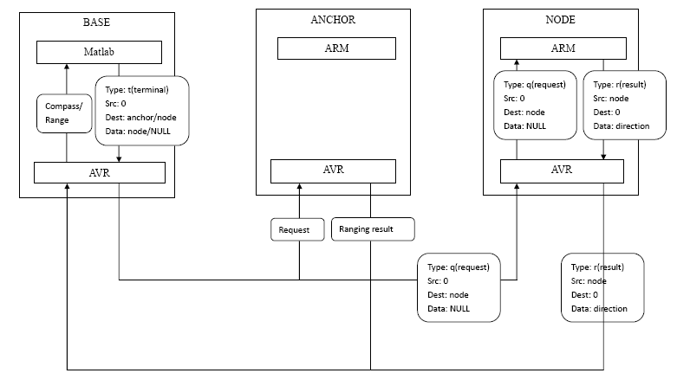
- Signature Test
  - The goal
    - The ranging reading between 2 radios has the trend to increase when the real distance between 2 radios increase
    - Even the changing in environment changes can affect single reading in a big way, the integrated signature’s Euclidean Distance changes less in ratio
  - We build a sphere using plastic pipes and fixed some SensorFly boards on it
    - We put one node in the center of the sphere and put 6 nodes 50cm away from the center in 6 directions, and we put another 6 nodes 150cm away from the center, in same 6 directions.
    - We find that also in different ratio and in a non-linear way, the ranging reading increase when the real distance grows.
    - But since the ranging distance is not stably increase within short distance, we pull one radio away from another across the lab and see clear increase in ranging distance.
  - We set 10 Anchors and located 5 Nodes in different places in the lab for signature test
    - We changed some settings of the environment once a while during the test, which lasted about 1.5 days
    - We intentional blocked one pair of Anchor and Node to see how the integrated signature can decrease the affect of the changing in the environment
- Generate Distribution Table
  - Assumption
    - The change in relation between real location and ranging distance, although is non-linear and can be effected by change of the environment, it does not change much for different pair
  - Experiments
    - Use multiple nodes to range, see if the reading changes a lot (? Cannot recall this part clearly :P)
      - Location: hall way
      - Use C# code to get readings spreading in 4 different directions
      - No figures required
    - Put 2 nodes in different rooms see if the same real distance can achieve similar ranging reading, when there is no obstacle between (? Cannot recall this part :P)
    - Put 2 nodes in hall way and get ranging readings every 10 cm away from each other, from 10 cm to 720 cm
    - Use the data in 4.2.3 to get distribution table of the real distance and ranging distance
- Experiments in Hallway
  - We tried to collecting data in grid all over the place and then do the interpolation to generate data, but we find the data generated by interpolation is not reasonable at certain point
  - So we tried another way: generating the signature using distribution table from ranging experiments
  - We used the distribution table to generate ranging readings for simulation
    - The anchors’ locations are generated randomly at first, and the clusters generated overlapped a lot
    - Then we realize that it is the locations of the anchors that effect the clustering, and through experiments
    - We realize that when the anchors are around the readings, which means the anchors are against wall, the clusters are in good forms
    - We also use the data to simulate the navigation part, and according to the simulation result, the system can be accurate as within 1 meter
- Experiments in Lab
  - With the experiments in hallway, we are confident that the algorithm of clustering and navigation is reasonable and useful
  - We divided the lab into 27 areas each about 1 meter by 1 meter and we input the start area and stop area then we let the algorithm do the guidance
  - We still use the old way to determine which cluster the reading is in: choose the closest one
  - But we collect the cluster info in each area, and if the area is consist mostly by a few clusters, ending in either one will be count as “arrived”
  - The problem is the accuracy is lower, since usually the cluster can be found in several different areas
  - The result shows that the system can guide, but it goes back and forth sometimes during the guidance (we haven’t find the reason yet…)
  - In order to find the reason why the guidance pointing back and forth sometimes, we need fast debug-able multiple process of test, so we decided to get signature readings every 10cm then we run the whole process with MATLAB
  - We took 20 ranging readings at each point on the grid that covers half of the lab and the compass reading to build the database of the lab
  - We run the algorithm, but to find that the overlapping of the clusters is severe
  - Then we did some analysis of the data, by getting standard deviation of the readings, and we find that some of the readings are not stable at all, probably due to the fact that the battery is low during the data collection
  - So we changed algorithm a little by using sub-set of the signature, and get rid of the unstable readings, and the overlap got much better
  - Still, we did not find the reason why the guiding can be back and forth sometimes, my assumption is that the inaccuracy of human movement results in getting in non-expected cluster, which happens to have a way firstly back, and due to the continuously inaccurate human movement, it goes back to the same cluster it comes from
- Experiments in Supermarket
  - With the

